Analog BMS Project Notes
Christopher Kalitin

Links
BOM: https://docs.google.com/spreadsheets/d/1S_8XwXVPueQ1eiFWQywlaV26638HY9bX2LvsAcdvjEg/edit?usp=sharing

Voltage Divider Testing:
https://docs.google.com/spreadsheets/d/1fG0IjSdaaXqMwqhgySdIyr8Wdc52NVvBKQQJ1HLR2iQ/edit?usp=sharing

GitHub:
https://github.com/CKalitin/analog-bms

Posts
Schematic Design Review:
https://x.com/CKalitin/status/1957609865859518632

It’s so beautiful:
https://x.com/CKalitin/status/1958013895609626868

Black PCB:
https://x.com/CKalitin/status/1958047737120977324

Pepe:
https://x.com/CKalitin/status/1958071000773587136

Bad Footprint:
https://x.com/CKalitin/status/1969834710554779652

LED lights up!:
https://x.com/CKalitin/status/1969946179267170740

Aug 17 2025
Project Requirements
- All analog components (No microcontrollers or any digital based components, eg. ADC-based programmable temperature switch)
- >1 year self-discharge period (no load, only BMS powered)
- At least a 3.3 V output. 5 V and 12 V if you’d like. (5V nice for small motors)
- BMS Safety Features (UV, OV, OC, OT), under temperature if you find an easy way.
- 1 A current draw (arbitrary, could base this off the cells too)

Analog requirement is just for fun.

The >1 year self-discharge period requires extremely low current draw components and low quiescence current for anything that’s only active when there’s a load.

3.3 V could be boosted to 5 V or 12 V on the application’s board. So not a strict requirement. 5 V is generally nicer than 3.3 V.

Under temperature is preferred but it may be difficult to find an analog temperature-controlled switch that can do it. Also, these switches would sense ambient temperature, not necessarily cell temperature.

Wait nvm I was being stupid, thermistors exist and you can use another comparator. Under temp isn’t too hard.

Circuit Design from LTO BMS rev1
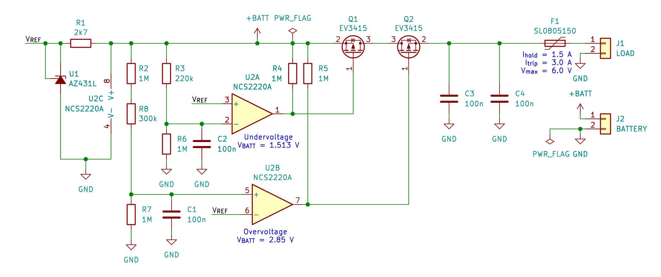
Mostly basing this project off rev 1 of this guys analog BMS:
https://uart.cz/en/2557/lto-bms-development-notes/

Use two comparators to drive two FETs. These use UV and OV voltage references. If one goes out of range, open its corresponding FET.

Have two FETs with opposite facing body diodes. Name them for their purpose, undervoltage Fet and overvoltage FET.

When the undervoltage FET opens, you can no longer discharge the battery, but through the body diode you can still charge it. (In the schematic above this is the FET on the left).

Undervoltage PFET:
High-side PFETs require Vs > Vg - Vgs(th) to conduct. If source is main pack voltage, and that have a minimum of ~2 V, then you can pull that to ground when you want to open the FET.

Overvoltage PFET:
This FET will have to be backwards (Drain to positive voltage, source to load) so the body diode is backwards. We still require Vs > Vg - Vgs(th). In this case Vs = 0 V when the FET is open. Hence we need a negative Vg.

Overvoltage NFET:
NFETs require Vg + Vgs(th) > Vs. Because it’s an NFET, source is to positive voltage and drain is to load. So, we need main pack voltage + Vgs(th) to drive this NFET.

Now it’s a trade off between creating a source of negative voltage (lower than pack GND) or boosting a voltage up above main pack voltage (and associated power losses from a boost converter IC on the analog low-power BMS).

Charge pumps can do both with low quiescence current. They do require specific input voltages usually (eg. 4.5 - 5.5 V).

Quiescence Current Component Selection

The ATtiny used in the Czech guys project draws ~50 uA in standby mode. Here’s a benchmark, I should not ever be above a microcontroller-based BMS quiescence current.
https://grok.com/chat/39336b2c-866d-4b45-97da-c78c1d86ad9a

IRF4095 PFET:
Gate-source leakage = +/- 100 nA
Zero Gate Voltage Drain Current (I_DSS) = -100 uA (at Vds = -100 V, Vgs = 0 V)

Idss is drain to source current, which is negative to up to 100 uA can be drawn from the battery when Vgs = 0 (ie. PFET open).

BSS84LT1G PFET:
Drain current (continuous) = -130 mA (already can’t use it)
Gate-Body leakage current = +/- 10 nA (at Vgs = +/- 20 V, VDS = 0 V)
Zero Gate Voltage Drain Current: -0.1 uA (at Vds = -25 V)

Zero gate voltage = (Vgs = 0 V)

Ok it’s possible to get very good quiescence current PFETs. Just will have to buy more because none of the two I have fit my application.

A 100k pull down at 5 V would draw 50 uA. Need to use extremely weak pull downs to minimize current draw. Well this assumes constant current draw. I could calculate the time constant of the capacitor and find how a weak pull down affects response time.

Required Components:
- PFET
- NFET
- Charge pump for NFET
- 2x Comparators
- 2x Adjustable Voltage Reference
- Resettable Fuse (temp controlled)
- Temperature Controlled Switch (Over temp)
- Passives (caps, res’)

If feeling like you have extra quiescence current budget:
- Thermistor
- Additional comparator
- Additional FET (pair of FETs? Want to completely isolate) (switch?)

Charge Pump / FETs
Assuming I’m using UBC Solar’s Molicels (INR-18650-M35A), Vmax = 4.2 V, Vmin = 2.5 V.

Continuous current per cell is 1.7 A, so 3.4 A total for two cells. Could set the fuse at 2 A.

First, NFET (DMN2056U):
- Rds(on) = 38 mΩ
- Id(max) = 4 A
- Vgs(th) = 1 V max (0.6 V nominal)
- Idss = 1 uA
- Igss = +/- 100 nA

Idss = Zero gate voltage drain current
Igss = gate source leakage current

Amazing option. $0.34 / unit at <10, ~2x more expensive that some others.

I’ve looked at a couple charge pumps that output -Vin and their quiescence currents are all on the order of 100 uA.

LTO BMS Czech guy also used a charge pump. Not clear how he used it from the schematic, but it is on there. I must make a more beautiful schematic. Another project requirement right here.

At Vbat = 4.2 V, I need 5.2 V from the charge pump. Or, -1 V.

This charge pump (LTC1754ES6-5) works:
- 11-30 uA operating current
- 2.0 - 4.4 V input
- Boosts to 5 V (For 4.2 V max Vbat, we’re below Vgs(th) max here, 0.8 instead of 1.0)
- But costs $6.75.

The only charge pump at 5.5 V output in stock (REG71055) has a 65-100 uA quiescence current.

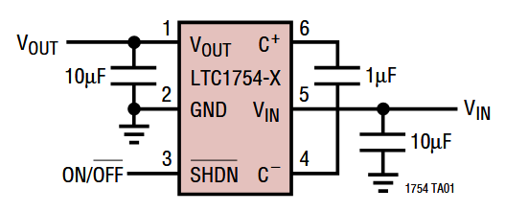

“SHDN (Pin 3): Active Low Shutdown Input. A low on
SHDN disables the LTC1754. SHDN must not be allowed
to float.”

Now, PFET:
Requirements: Quiscence current ~1 uA, Vgs <= 2 V, Id (max) >= 3 A.

PFET (DMG2305UX-7):
- Rds(on) = 52 mΩ
- Id(max) = 4.2 A
- Vgs(th) = -0.9 V max
- Idss = -1 uA
- Igss = +/- 100 nA

Comparator:

Now this is getting into components that might not tolerate certain Vcc’s. Need to operate in 2.5 to 4.2 V range.

Also look out for hysteresis. Don’t pick a value that too high.

Hysteresis works with a high threshold (Vth) and a low threshold (Vtl)
Vth = Vref + Vhys/2
Vtl = Vref - Vhys/2

So for Vref = 2.5 V and Vhys = 0.05 V, Vth = 2.525 and Vtl = 2.475 V

This means that for a 50 mV hysteresis, you need to set your voltage reference 25 mV higher than the batteries minimum voltage. Then, once voltage rises to 50 mV above the minimum voltage, it can draw current again.

Grok says EMI due to switching loads or charger ripple could be 5-20 mV. Hysteresis should be peak-to-peak voltage, ie. +/- 10mV noise = 20 mV hysteresis. I’m fine with 50 mV for my application then, make it extra noise resistant.

50 mV (max!) hysteresis comparators cost ~$7. Others are ~$1.

Comparator (TLV7031-Q1):
- Supply voltage = 1.6 to 6.5 V (recommended)
- Hysteresis = 2 to 17 mV (6.5 mV typical), or 10 mV typical for 2 or 4 comparator ICs
- Supply current / channel = 390 nA (typical), 900 nA (max)

The dual or quad comparators have greater hysteresis and lower supply current / channel. Since I need two minimum anyway (maybe another for the under temp), use the two comparator version. (TLV7032).

Voltage Reference

LTO BMS Czech guy is using this voltage reference, with 55-80 uA minimum cathode current for regulation (Ika). Far too high. I can’t use an adjustable shunt regulator.

A shunt regulator varies the current running through it to modulate the current going through an up-stream resistor. By ohm’s law, the current through that resistor changes the output voltage.

A series regulator changes its own resistance to modulate its own voltage drop, so net voltage output maintains a given value.

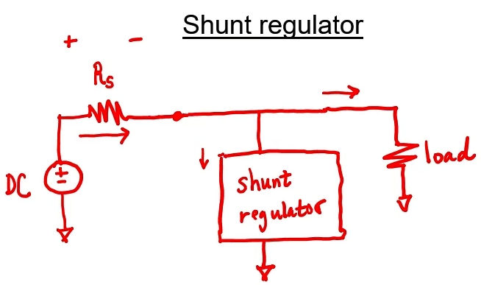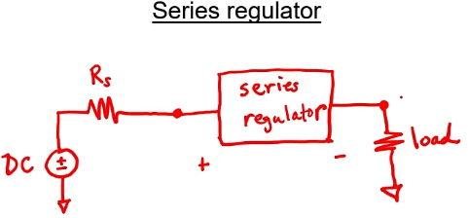

Shunt regulators have far higher on currents (minimum cathode current) than series regulators.

Quiescence current is when I_out = 0 ma, so it can be specified as I_gnd (I_out = 0) = X.X mA

Voltage Reference (TPS7A2401DBVR):
- Vin: 2.4 to 18 V (recommended)
- Output voltage (adjustable version): 1.22 to 1.26 V (1.24 V nominal)
- Quiescence Current: 4.5 uA (max), 2 uA (typical)
- $0.58

VOUT = VFB × (1 + R1 / R2)

Vfb = 1.24 V nominal

Datasheet section 8.1.4:

Reverse current flows through an intrinsic body diode in the device. High reverse current grades the device. The voltage drop of the body diode is 0.3 V. So, if Vout > Vin + 0.3 V, you get reverse current.

Reverse current could occurs if cells are disconnected from the PCB. Eg. while assembling I’ll have to get the tabs in place and they won’t be soldered down well. If pos and ground get connected, then I disconnect them, you’ll get reverse current.

The solution is to put a Schottky diode for reverse current to have a different path:
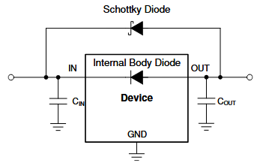

TPS7A2401, “01” means it’s the adjustable version.

Quiescence Current Requirement

2 Molicel’s have a nominal capacity of 7000 mAh.

Using the 50 uA of the ATtiny MCU the LTO BMS uses, we get:
7 Ah / 0.00005 A = 140,000 hours / 24 / 365 = 16 years

Two is the reasonable lower limit of the cells I’ll use because the PCB needs to be big enough to fit all components and connectors.

So, we’re passing our 1 year self-discharge requirement with flying colours. I can increase that to a 10 year requirement for safety. Really, having a battery in the back of my mind to charge in a year is too much effort.

A solution is to have a jumper that disconnects the BMS from the battery (also disconnects load obv). This won’t actually be required though!

Hopefully at least once a decade I’ll have a need for the battery.

PPTC Fuse

Polymeric Positive Temperature Coefficient (PPTC). These fuses trip when hot, reset when cooled. “Resettable Fuse” is important too!

PTC Resettable Fuse (SMD0805B110TF):
- Hold Current: 1.1 A
- Trip current: 2 A
- Max current: 200 A

Note that hold current is the recommend continuous current without tripping under 25 C. I_hold decreases with higher temperature.

Temperature Switch

The datasheet of the cell says -40 to 60 C discharge and 0 to 60 C charge. This is greater than Solar’s current cells.

Looking at Thermostats - Mechanical on Digikey there exist none that switch at 50-55 C and have a max current greater than an amp. Also barely any in stock. Looks like I’ll have to use thermistors and comparators.

All 2A mechanical thermostats have a minimum of 110 C switching temperature and 7 to 15 C tolerances!!

Temperature FET Control

Open-drain comparator (Different model of the existing one) (TLV7043DGKR):
- Supply voltage = 1.6 to 6.5 V (recommended)
- Hysteresis = 10 mV typical for 2 or 4 comparator ICs
- Supply current / channel = 390 nA (typical), 900 nA (max)

Rail-to-rail input capability means it supports voltages in the range of both inputs. For me this would be GND to B+, so we’re all good.

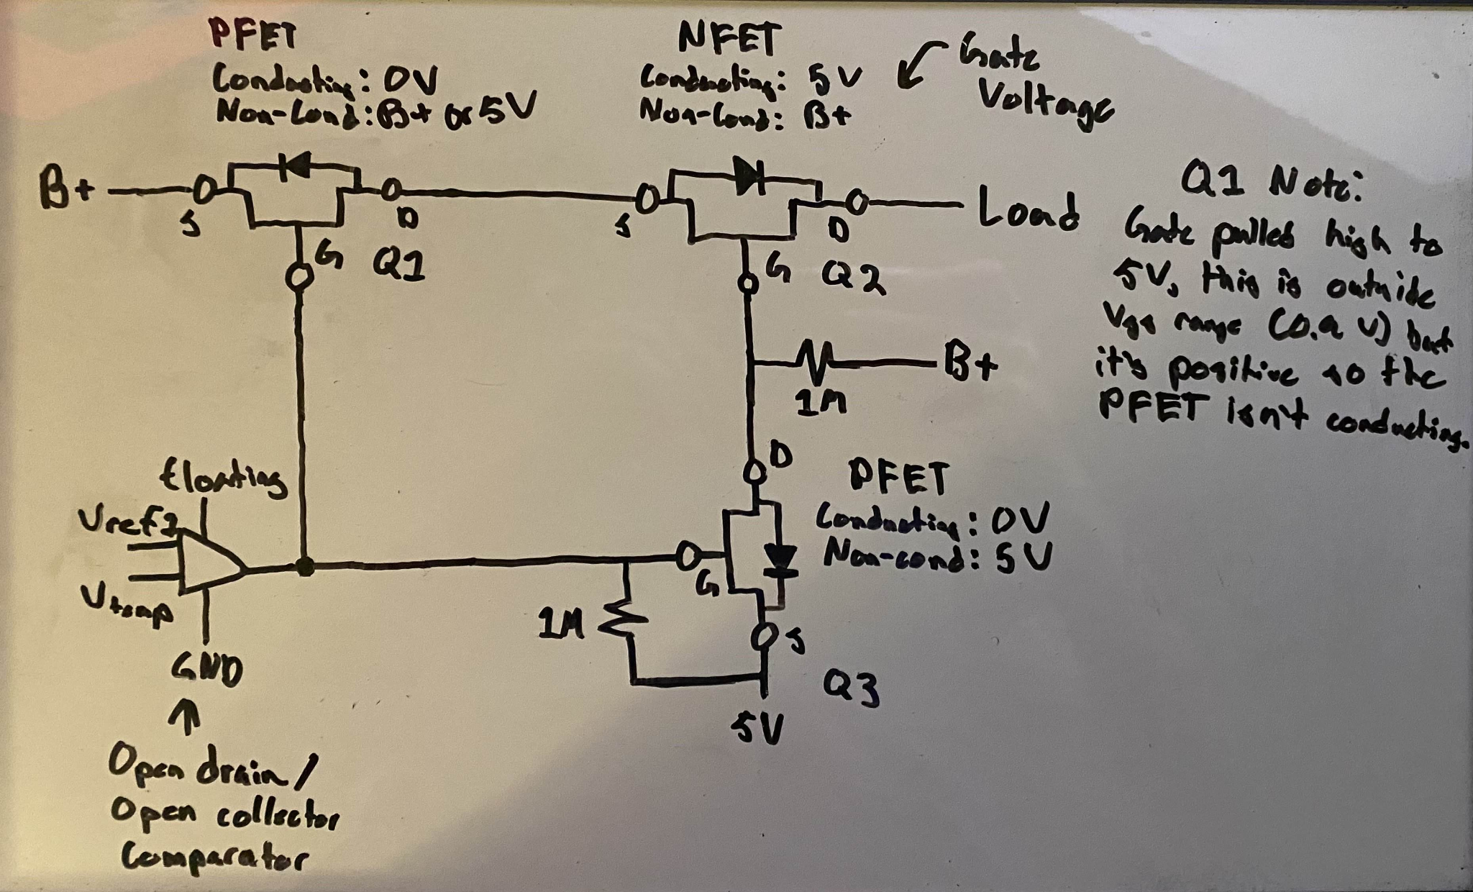

Above is the circuit I’ll use to let the two temperature comparators control current flow.

The comparator is open-drain, so it either pulls the voltage to GND or leaves it floating.

We are powering the gate of the PFET on the power line (Q1) with 5V. This is greater than battery voltage, so Vgs will be positive.
Vgs(th) on the PFET is -0.9 V, so it conducts when voltage is 0.9 V less than gate voltage. So, it should be fine to drive the gate to a higher voltage than source and it still shouldn’t conduct. This is what Grok and Reddit said, but I’ll test it myself.

Shit it doesn’t work. It’s either pulled down to floating. So if we have two comparators on it, if we have an over temperature one of them will go to floating while the other still brings it down to ground. So FETs still conducting.

I could use an or gate? Another component though, there’s a more elegant solution here. Think harder.

A latching relay is becoming an easier and easier solution. High current draw for 100ms, then nothing. And this only occurs during over/under temperature events. Just need to create an analog 100ms high current, then nothing. These circuits exist, consult The Art Of Electronics.

I could make both comparators default floating, when a temperature is out of range the comparator output is GND. This provides a current path for a PFET to turn on and pull Q1 and Q3 gates high.

However, this would be a MOSFET controlling a MOSFET controlling a MOSFET. More elegant!

PFET gate would be pulled to 5 V, source would be 5 V, drain would go to the other gates. When temperature goes out of range the gate would be GND, the PFET would conduct, and the other gates go to 5 V. Nominally they’ll be GND so that they’re conducting.

Wait! I could make a open-source comparator by putting a diode on the output of the comparators! Now you can make the ‘other gates’ default 0 V so they conduct, but if either temperature is out of range, 5 V conducts to the other gates, opening both.

Perfect! This way I don’t need another PFET. But it is still 2 more component, just simpler ones. Passive, but non-linear. The diodes would have a voltage drop, so choose a Schottky with ~0.3 V drop so that the gate of the PFET Q3 is 4.7 V versus 5 V source, so it still is non-conducting.

I like this solution way more than the PFET option. I need schottky’s for the voltage references anyway. This also simplifies the BOM since I don’t need a separate open-drain comparator.

Aug 18 2025
Breadboard Temperature FET Circuit
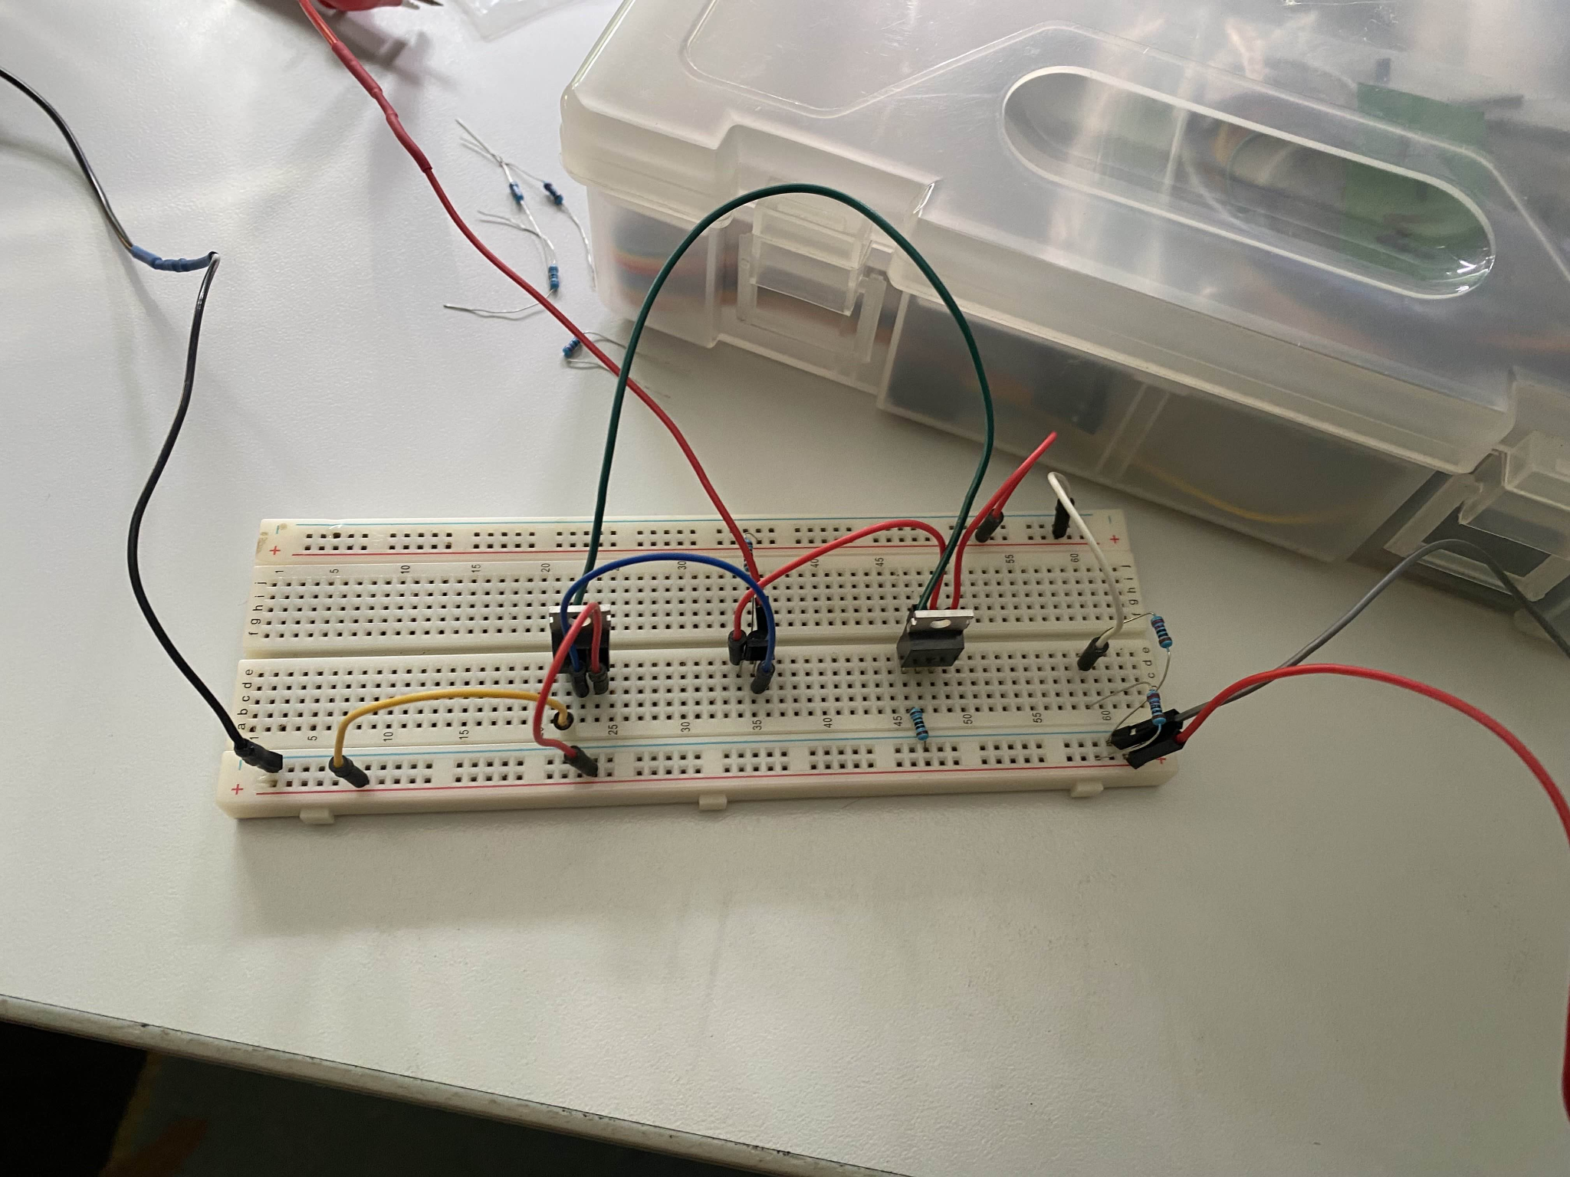

It works first try!
Interesting notes:
- With the gate line pulled to ground PSU current draw is 16 mA. Meanwhile, power draw on the equivalent of the B+ to load line is 0 A (meaning the circuit works but 16 mA is being drawn somewhere)
- I’m using 1k’s for the voltage divider (simulating B+ at 2.5 V) and the pulldown to GND on the gate line. Current draw through both of these is ~7-8 mA each.

So, 1k’s are drawing ~5 mA each, as expected (Well ~7 mA is weird but in the same order). Didn’t expect that when I first made the circuit was slightly confused.

Each 1M I add to my design is ~5 uA of current draw. Extremely high, limit your use of them.

Thermistor

Thermistor (NT08565F4050B1F):
- 25 C Resistance: 560 kΩ
- 5 C Resistance: 1460 kΩ
- 55 C Resistance: 161.7 kΩ

With 5V source and a 1M second resistor we get a voltage range of 2.033 V to 4.304 V.

On the low end, one degree of difference is ~60 mV.
On the high end, one degree difference is ~20 mV.

Using a 560 kΩ to get the best range relative to the 1M second resistor in the divider.

A voltage reference and 5 V source actually isn’t a requirement here. It’s all just voltage dividers, so they’re agnostic to the source voltage since it’s all relative to the same source voltage. It works the same with 2 V or 5 V, it’s just that the comparator’s precision and hysteresis becomes more of a variable.

~4.5 C is 1500 kΩ. Do this with a 1M in series with two 1Ms in parallel. 1500 kΩ equivalent.

~49 C is 200 kΩ. Use two 100k’s in series.

At minimum battery voltage we get 2.5 V.
Range: 1 V to 2.083 V.
1 C delta: 30 mV and 13 mV

With typical comparator hysteresis of 10 mV, we’re at less than 1 C hysteresis. Not bad!

Comparator input offset voltage (precision as I understand it) is typically +/- 0.1 mV, up to +/- 8 mV. Again, less than a single degree of error. Perfect!

The thermistor’s resistance precision is +/- 1%. 15 kΩ and 2 kΩ. This is again less than a single degree. Again we’re good!

This worked out great, easy design. Hopefully the circuit actually works now.

Voltage Reference Resistors

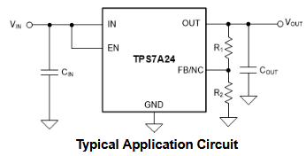

TPS7A2401DBVR

VOUT = VFB × (1 + R1 / R2)

Vfb = 1.24 V nominal

I need 2.5 V and 4.2 V as references, and with max comparator hysteresis of 25 mV.

So, 2.525 V and 4.175 V.

2.525 = 1.24 * (1 + X)
Vout / Vfb - 1 = X
2.525 / 1.24 - 1 = 1.036

If I use a 1:1 ratio I get 2.48 V for the minimum. Too low! This is a situation where mV matter. Slightly bad design maybe if it’s this susceptible.

I could limit the range to 2.55 V and 4.15 V for safety.

2.5 / 1.24 - 1 = 1.056
This can be achieved with two 1M’s and a 50k

4.15 / 1.24 - 1 = 2.347

3.33 * 1.24 = 4.123 V

2.33 / 1 can be achieved with 3x 1Ms in parallel then a 1M in series, voltage tap, then a final 1M.

Or, 1.0951 / 0.470. A 1M and 100k in series, then a 470k at the bottom of the divider.

Cin recommended as 1 uF. Cout recommended as 2.2 uF, 1 uF (min), 100 uF (max). Ok 2.2 uF it is. I could get away with 2x 1 uF though!

Schottky Diode

Schottky Diode (RB751V40T1G):
- Forward voltage: 0.28 V (typical), 0.37 V (max)
- Reverse Leakage 300 nA (typical), 500 nA (max)
- Max Current: 30 mA

Might need a current limiting resistor before the gates of the capacitors. Doesn’t need to be a 1M either, could be 10k for example, just limit the current while the inherent capacitors charge.

Screw Terminal

Side entry 2 pos.

Green (691137710002): $0.36
Black (691502710002): $0.62

(Same dimensions)

Yes I’ll pay extra for aesthetics. Black PCB too.

Pink cells though I think. Oh well!

Now how am I going to do the return path! The negative of the batteries will be on the bottom of the module, away from the PCB!

Czech guys batteries might have pos and neg on just a single end.
https://x.com/vascocz/status/1831566882962358400/photo/2

I can just use a 16-14 gauge wire for the return path. The ATX PSU Motherboard wires I have are 14 AWG, I can just use those. I have enough length for ~4 modules. These have a ~15 Amp current limit. Solder one end to the nickel tab (before spot welding) and the other directly into a hole on the PCB.

More Comparator Selection

For comparators I’m going to use the -DDFR version because it’s a smaller package.

Also, the under voltage comparator needs a B+ output, over voltage comparator needs 5 V, and the temperature comparators need 5V output. So, I need three comparators (or two and don’t use one of them on the four). I can use two single comparators for the OV and UV, and a one dual comparator for the temperatures.

Comparator naming scheme:
TLV70XY

X = 3 = push-pull
X = 4 = open-drain

Y = 1 = single comparator
Y = 2 = dual comparator
Y = 4 = quad comparator

-Q1 = rail-to-rail

Single SC-70 Push-Pull Rail-to-Rail Comparator: TLV7031QDCKRQ1

Dual SOT23-8 Push-Push Rail-to-Rail Comparator: TLV7032QDDFRQ1

It’s so beautiful

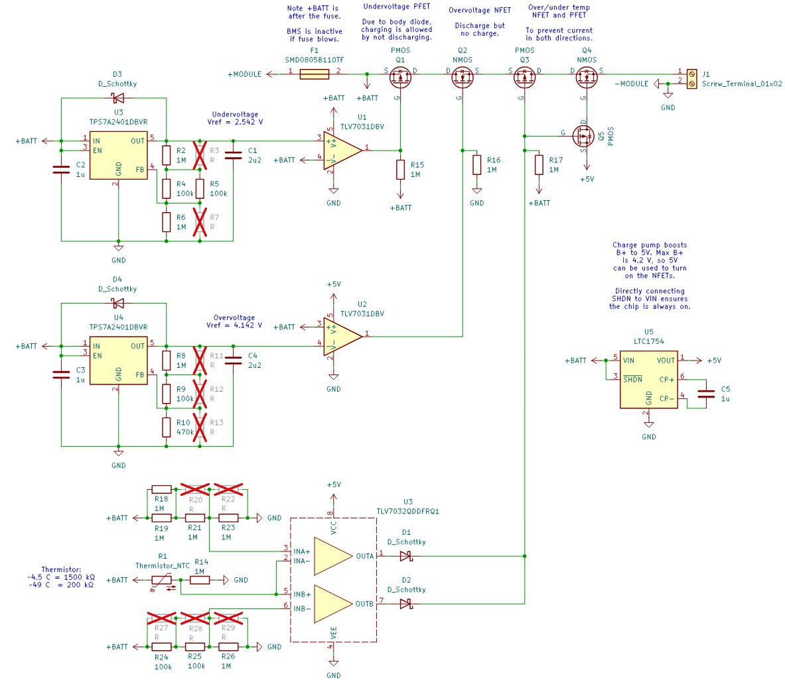

Nvm this one does not inspire joy:
- Should combine logic on signal-side instead of power-side. Only have two FETs on the power line.
- NFETs have lower drain current at low Vgs, so I currently have a 100 mA limit at 25 C and 0.8 V Vgs (5 V & 4.158 V).
- To solve this I’ll limit battery voltage to 4 V which gives ~1 A max. I’ll also bring down the resettable PTC fuse to 1A.

Resettable PTC fuse (1 A trip, 0.5 A hold): SMD0805B050TF

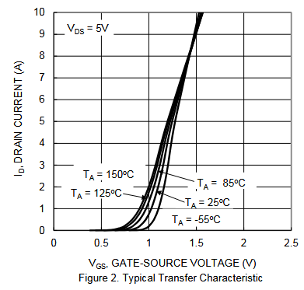

Correction about my ATX PSU Motherboard wires, their diameter is ~1.05 mm so they’re 18 AWG. This is still ~10 A current max so we’re fine. It’s also 7 cm. 1.5 mm THT should be fine for this.

To fit all components I need to have 4mm extra on all sides of the cells, relative to the PCB.

A disconnect header is tall enough that a standard one would be taller than the screw terminal connector. I’ll rely on my self-discharge period being a decade and not include it. Lithium Ion cells that get completely discharged seem to be fine, they just don’t produce any current anymore and cannot be revived.

Again, so beautiful
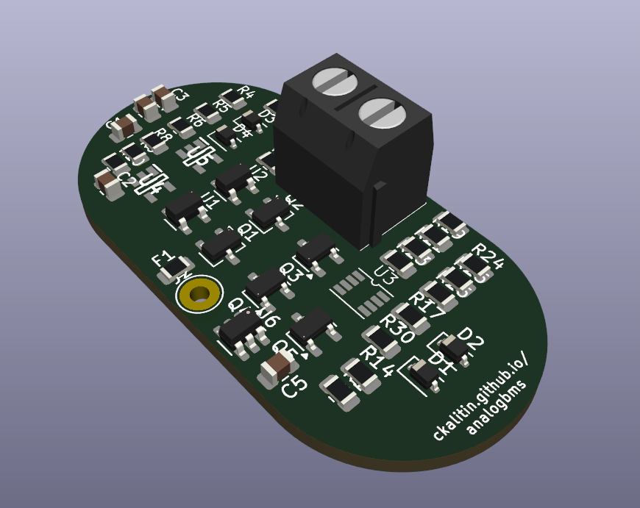

Aug 17 2025
Screws

Black oxide finish on McMaster is ~50-60% more expensive than the plain metallic look. I’ll spend extra for the aesthetics.

Screw:
https://www.mcmaster.com/products/screws/thread-size~m3/length~14-5-mm/finish~black-oxide/socket-head-screws-2~/
Get the fully threaded ones!

Nut: https://www.mcmaster.com/90593A001/

Using M3 because I have M3 black oxide finish screws lying around from what I thing was a water cooling block for a GPU, I don’t exactly remember it’s strange.

CAD

Insulation around an 18650 might be ~0.1-0.2 mm. Grok says manufacturing tolerance is 18.0-18.5 mm and 65.0 - 66.0 mm.

I’ll make cell holders 18.7 mm in diameter (Will need to account for 3D print changing size) and build in margin for a 1 mm longer cell.

Old cells in drawer before bathroom: 18.3 mm 64.8 mm

With protective insulation covering on the ends of the cells, 65.3 mm

Solar’s nickel tabs (from AliExpress!) are 8 mm in width.

I’m certainly going to make a lot of rookie mechanical design mistakes. That 1mm cut in the center for the tab? Weakened area exact where you want more strength!
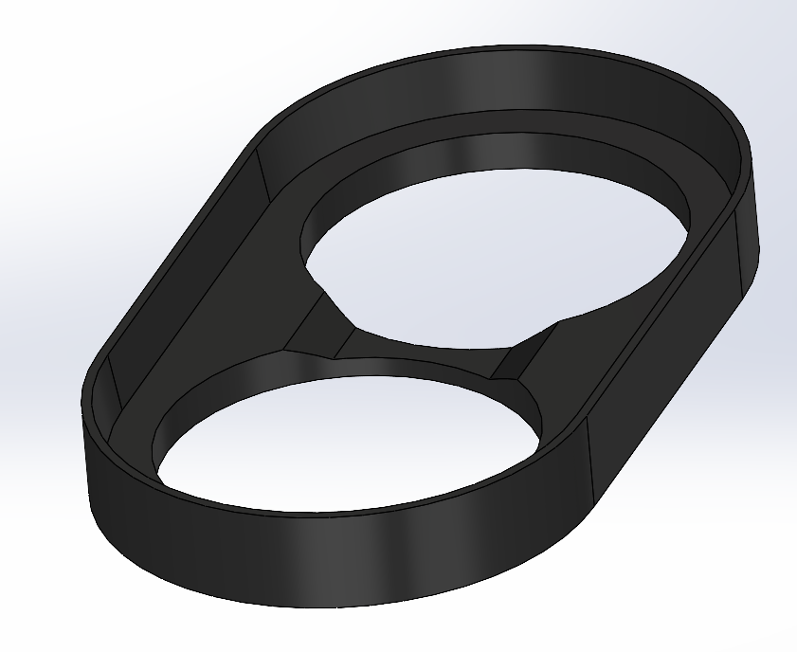

3D prints will extend 1.5mm past the PCB in every dimension. 0.5 mm on each side for PCB clearance, 1 mm for the wall.

18650 diameter will be 18.7 for holder parts.

M3 screw hole is 3.2 mm for clearance.

18 AWG are ~1.05 mm in diameter and get 1.5 mm holes.

I could put some foam inside the battery holder plates on each side so the batteries don’t wiggle around.

PCB is 1.51 mm thick according to the exported .step in solidworks. Measuring my other PCBs I get ~1.6 mm. If using just the tip of the calipers and pressing I get ~1.5 mm.

The connector is 10 mm tall, 10 mm wide, 7 mm long. And is offset 0.75 mm from the edge of the PCB. I’ll allow for 0.5 mm clearance on all sides.

The gap between the top plates has to be 1.5 mm + 10 mm - top plate thickness.

My standard thickness for end plates has been 2 mm so far. 1mm for side walls.

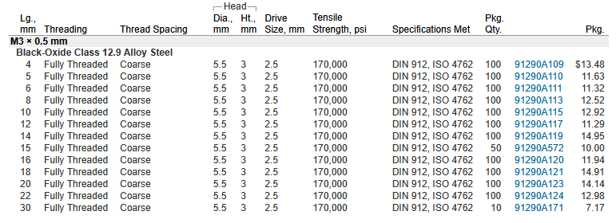

100 15mm long M3s are $20 while 100 16mm long M3s are $11.94. I’ll go with 16 mm length.

I need 18-20 mm long screws

18 AWG Current wires will be 3 mm from the outside edge of the print. This means 3 mm - 1.5 mm = 1.5 mm from the edge of the PCB. 1 mm is the wall width, 0.5 mm PCB margin.

Screw holes remain 3.5 mm from the outside edge (measured wrong earlier). This is 2 mm from the edge of the PCB.

It’d be a good idea to have spaces for other 3d printed mounting holes on the PCB. To constrain rotation.

Redoing OV / UV Circuitry

Chris Jack made a very good point.
https://x.com/ee44cd/status/1957650349071769760

Instead of using two voltage references with the associate capacitors, diode, and mess of resistors, just use a single voltage reference for a standard voltage less than 2.5 V. Eg. 1 V. Then, use voltage dividers on BATT+ to get UV and OV reference voltages in reference to that 1 V.

https://www.digikey.ca/en/products/detail/texas-instruments/TPS71518DCKRM3/17395010

Voltage Reference (TPS71518DCKRM3):
- Output Voltage: 1.8 V
- Recommended Input Voltage: 2.5 V - 24 V
- Quiescence Current: 3.2 uA (typical), 4.5 uA (max)
- Input Capacitor: 1 uF (typical)
- Output Capacitor: 1 uF (min)

“No connect pin. This pin is not connected internally. Connect this pin to ground for best thermal performance or leave floating.”

I’ll connect to ground.

This one also recommends a diode for reverse current protection. Likely not needed given what Chris Jack said but I’ll go with it.

The reference voltage is now 1.8 V.

For UV I need to divide 2.7 V into 1.8 V. Perfect ratio. 500 kΩ + 1000 MΩ.

For OV I need to divide 4 into 1.8 V. 600 kΩ and 500 kΩ gets 3.96 to 1.8 V. Within 40 mV I’m fine with it.

Also note that this voltage range is trying to get as close to 2.7 and 4 as possible, no need to account for the hysteresis range and get a little higher since we’re not at the very limits of 2.5 and 4.2 V.

UV: 2x 1000 kΩ in parallel
OV: 2x 1000 kΩ in parallel then a 100kΩ in series. Then the ground resistor is 2x 1000 kΩ in parallel.

TODO: Update CAD with 4mm from center for the 18 AWG Holes.
Done

For PCB-equivalent thickness prints go with 2 mm thickness. 1.5 mm is too small to get a good print on the Ender 3 v2 and it’s shorter than PCBs anyway (Solidworks is 1.5 mm).

I’ve moved the connector 0.5 mm closer to the edge of the board to fit the reference designators for the FETs in the gap.

Moved 18 AWG through holes 0.25 mm up, was breaking a PCBWay design rule.

Add + and - indicators on the print!!!!

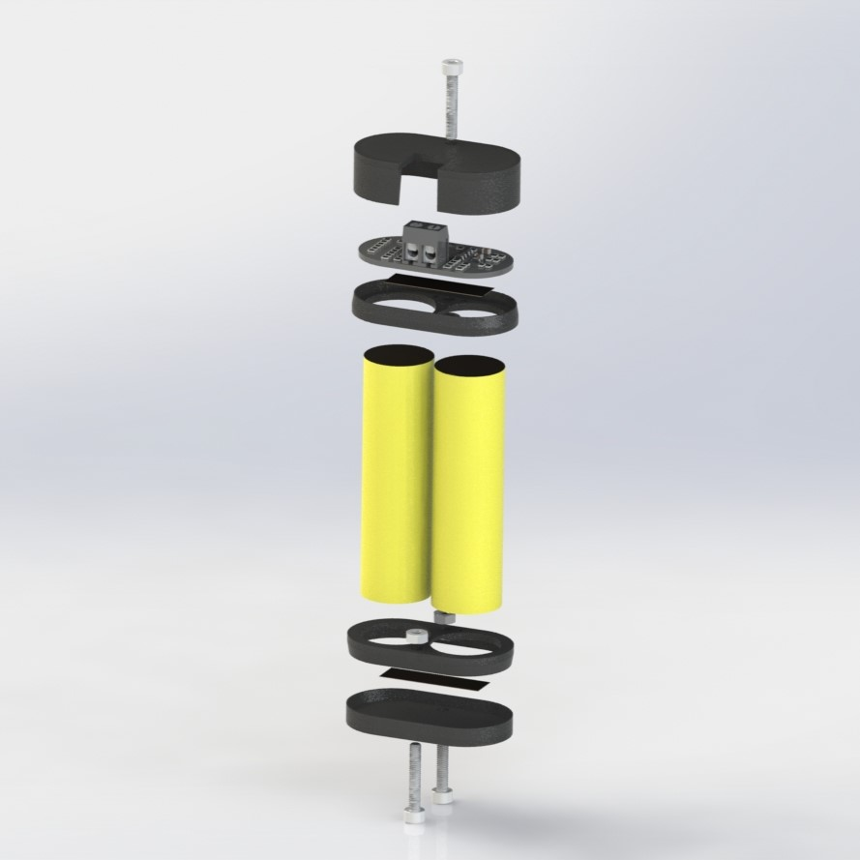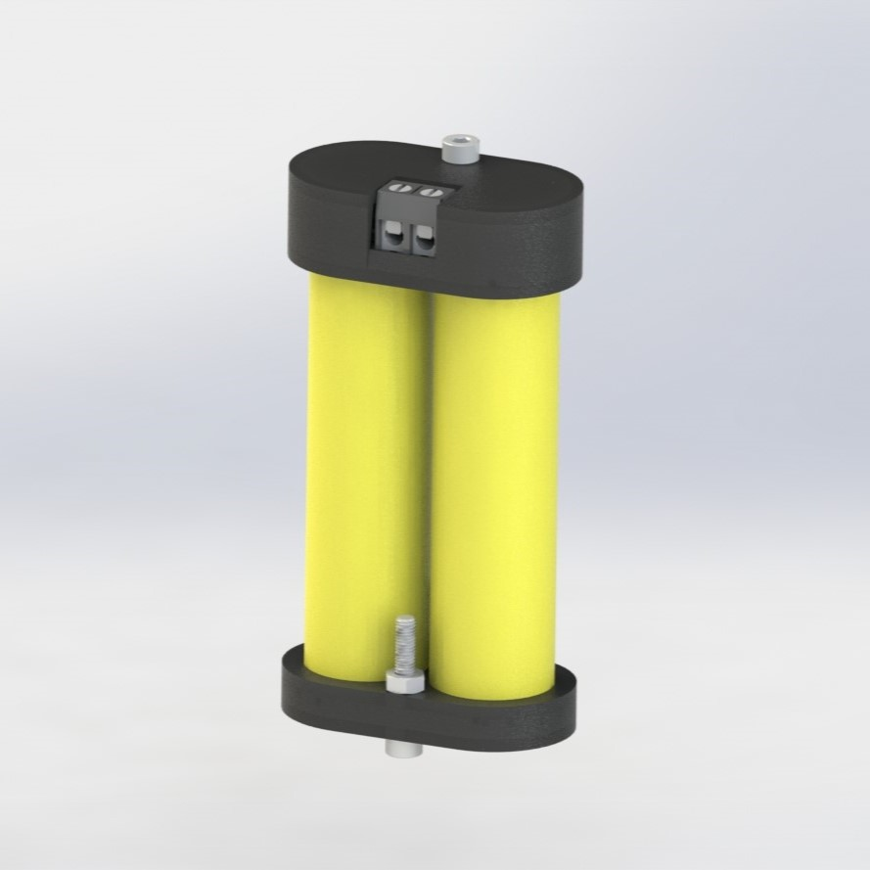

Also, this design is absolute shit.

- There are prints that must be installed being the nickel tabs are welded on and can’t be removed / replaced afterwards.
- You don’t actually need screws
- PCB isn’t properly secured
  - Rotation is only constrained at one point (screw). With 0.5 mm margins on each side this is not enough to make it feel nice.
  - The PCB isn’t held down anywhere. Add 3d printed clips.
- The wire from the positive (top) of the cells to the PCB is kind stupid, it should be a nickel tab welded to the PCB. Do I have the space though! If no screw, then maybe.
- 3D Printed parts should be snap on, this can be done with good strength. This eliminates the need for screws.
- If screws, countersink them to make it more beautiful and so it performs better during CFD.
- The bottom of the screw terminal pins would be touching the nickel tab, effectively shorting MODULE- and positive output to MODULE+. Very stupid design. Design the 3D print such that this is impossible.

I need to do a revision centered around removing screws and making everything clip on and replaceable.

This may involve soldering more to the nickel tab. Don’t make solder joints structural joints! But what other option is there? Screw into the nickel tab..? NO STUPID! That’s the negative of the battery dumb fuck. You don’t do that.

Good idea to put electrical tape on all exposed MODULE connections.

Aug 23 2025

I’m ordering from Mouser because the TLV7032QDDFRQ1 is not in stock on Digikey. Also going to order resistors and capacitors to ensure they’re of good quality, not content with aliexpress ones for the voltage dividers. Really only the 1M and 100k’s need to be legitimate. Going with 1% resistors so they cost $0.06 at 100 units instead of 5x the price.

Nvm that comparator is also not in stock on Mouser. Shit.

Both are in stock on TI!!!

I ordered TI components from TI, all others from digikey because thats the only place the thermistor is in stock.

Also, I have no reel of 1Ms. Would need to order either way.

Aug 27 2025

I really should’ve made it a 4 layer board, it was sponsored too so there’s not cost increase! Make the two inner layers ground for a lower resistance return path! This is good design principles.

Aug 29 2025

I didn’t properly consider the forward voltage drop of the FETs body diodes.
OT / UT FETs forward voltage drop doesn’t matter, since if they’re open we’re not conducting at all.

NFET Body Diode Forward Voltage: 0.7 V (nom), 1.2 V (max)

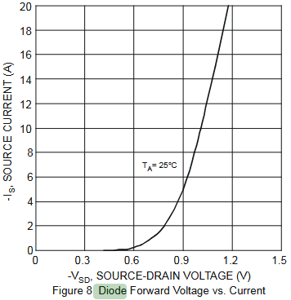

Note: Source-drain is the direction of the body diode

PET Body Diode Forward Voltage @ 1 A: 0.7 V

Note it’s not a hard cutoff which is slightly strange, though it is an intrinsic body diode. I need to understand this from the atoms and electrons up.

Sep 14 2025
Assembly and reflow went well!
Everything seemed to reflow / melt around 130 / 140 C, which is slightly strange but that feels like the melting point of the solder / flux in solution.

Good amount of flux residue on it so still need to use isopropyl.

Functionality Testing:
- Undervoltage
Put PSU on + and - through holes and probe Q1 drain to source with continuity mode DMM.
Do test with nominal voltage (eg. 3 V) then non-nominal voltage (eg. 2 V).
Find the precise threshold.
- Overvoltage
Put PSU on + and - through holes and probe Q2 source to drain with DMM.
Test 3 V then 5 V.
Find precise threshold.
- Undertemperature
Short thermistor voltage divider middle tap to GND
Then continuity from source to drain on Q3
- Overtemperature
Short thermistor voltage divider middle tap to BATT+
Then continuity meter from drain to source on Q4
- Current consumption
Note down PSU current from + to -

Voltage Divider Tests:
- Undervoltage
For 3 V between module + and -, probe GND to non-inverting input to U1.
- Overvoltage
Same but U2 inverting input
- Undertemperature
Same but U3 INA+
- Overtemperature
Same but U3 INB-

Voltage References:
- 5V (Pin 1 of U6)
- 1.8 V (pin 5 of U4)

Sep 20 2025
Got some strange results from testing, so decided to do an LT Spice sim.

I didn’t update the OV voltage divider after doing the calcs on Aug 17 2025.
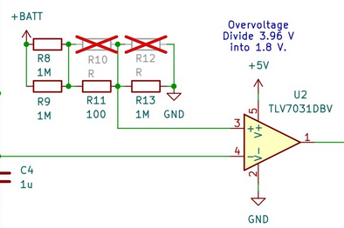
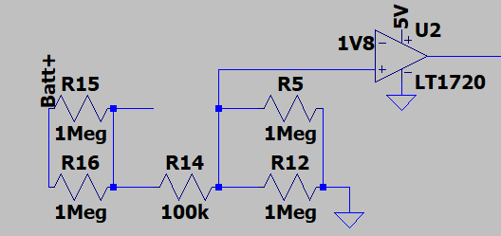

Now I got UV and OV resistors swapped. I’m going to sleep.

Sep 21 2025
UV: 500 kΩ || 1000 MΩ
OV: 600 kΩ || 500 kΩ

UV: 2.7 V -> 1.8 V
OV: 3.96 V -> 1.8 V

UV is usually > 1.8 V, when it goes above, fault.
OV is usually < 1.8 V, when it goes above, fault.

So I didn’t get it backwards?

Net / Condition | UV State (2.7 V) | Nominal State (3.5 V) | OV State (4.0 V)
UV Ref (V) | 1.8 V | 1.8 V | 1.8 V
UV Div (V) | 1.8 V | 2.333 V | 2.667 V
UV Condition | UV Div < UV Ref | UV Div < UV Ref | UV Div < UV Ref
UV Status | Open | Closed | Closed
OV Ref (V) | 1.8 V | 1.8 V | 1.8 V
OV Div (V) | 1.227 V | 1.591 V | 1.818 V
OV Condition | OV Div > OV Ref | OV Div > OV Ref | OV Div > OV Ref
OV Status | Closed | Closed | Open

* Condition is what’s required for the FET to open
** bolded = active condition

A better visualization tool would be useful for this kind of logic.

Comparator Current Source Issue

https://chatgpt.com/c/68d029d4-4088-832a-9507-9fca46f757e9

My voltage dividers have equivalent resistances of megaohms. This means current is very low uA, as I wanted initially.

However, the UV and OV voltage dividers input into a comparator’s non-inverting input, and that pin is sourcing a very small amount of current (2.1 uA in LTspice) which is great enough that it changes voltage divider current.
The voltage of the non-inverting output goes to the 1.8 V inverting-input, so our voltage divider output goes to 1.8 V. Chat says this could be due to cross-coupling to the reference input.

I haven’t gotten far enough in Practical Electronics For Inventors to really know how a comparator or op-amp works, so a deeper explanation can be saved for later. For now, I just know I need higher current.

During testing I was drawing ~20 mA from the PSU anyway, so something else in the design is also drawing far more than expected. Drawing 250 uA instead of 2.5 uA through voltage dividers isn’t too bad in this experimental PCB context.

LTspice:
Both left 1Ms: -746 nA
Middle 100k: -1.49 uA
Both right 1Ms: -1.8 uA
Non-inverting input: ~ -2.1 uA

KCL works here because we have a 2.1 uA input (comparator), 3.6 uA output (2 1Ms to GND), and a 1.5 uA input (top of voltage divider). Perfect values!

Next up is getting every single voltage on the real PCB and comparing to the LTspice sim.

https://x.com/CKalitin/status/1969834710554779652

All FET footprints are wrong.

Datasheet:
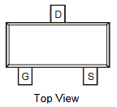
KiCAD:
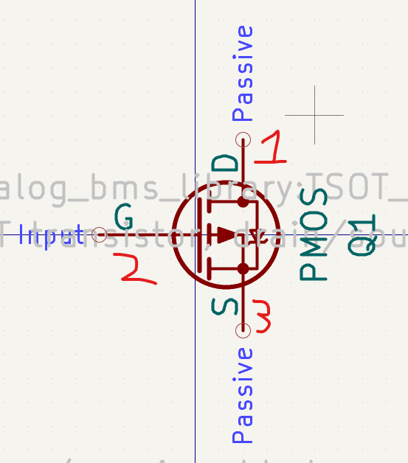

All resoldered on but rotated ~90 degrees. Now getting 400-600 on the multimeter in continuity mode when probing from drain to source on PFETs and source to drain on NFETs, this is as excepted, we should get a voltage drop over the body diode.

It also doesn’t look have bad, components at ~20 degrees from the x or z axis that are fairly symmetrical isn’t too bad.

Now the failure mode is that sometimes it outputs 3.89 V, sometimes 3.26 V, never exactly input voltage of 3.48 V.

If I drop it on my desk a couple times, the behaviour changes. I’ll try directly soldered PSU connections.

Replacing Q5 did not fix it. PFET.

My current instinct is that all issues with strange / “undefined” voltages is due to those points being slightly floating. Ie. the FET is open and it goes to some weird value.
When I put a 220 ohm resistor from positive to negative output, some of the strange voltages were solved, the voltage of the final drain of Q4 and on source of Q4. When I replaced the OV divider resistors, it solved the voltage on the output of the OV NFET.

I solved it and the LED lights up!!!

I needed a strong pull down (I used a 20k which didn’t work, then a 220 ohm) on the Q3 / Q5 gates. This pulled the gates to ground and made Q3 & Q4 conduct.

I also fixed the voltage divider for the OV FET, just soldering SMD resistors, and it showed the expected result. Before it was dividing too far down I think and making Q2 gate 0 V, non-conducting since it’s NFET.

Now just to explore a little more into the Q3/4 gate voltage issue (I saw 5.3 V at times! The charge pump doesn’t even get that high!), and it’s pretty much a complete project. Also tests! Still need to do all tests! LED did turn off at low voltage <=2.7 V, but not for >4 V, I got to 5 V and it stayed on for OV FET isn’t working quite as expected.

Overall, very happy. Extremely happy. Now for ODE homework!

Sep 28 2025
Multimeter testing at different voltages has been going fairly well.

I got one strange failure mode where the Q5 gate became 5 V (I think through the source of Q5 somehow?), while the diode inputs from the comparator was 0 V. When the ~200 ohm THT resistor that I put there for debugging was connected from gate to GND, the voltage went to around 3.5 V.

I also saw a drop of ~0.3 V from the 5V charge pump output to the gate. See “PCB_Voltage-Labels_4_Thermistor-Comparator_No-200-ohm.pdf” in tests folder on GitHub.

I just went over that PMOS with a soldering iron and the issue was fixed. Strange.

Diode reverse current is ~0.01 uA, should be fine and not impacting anything too much.
https://www.onsemi.com/pdf/datasheet/rb751v40t1-d.pdf
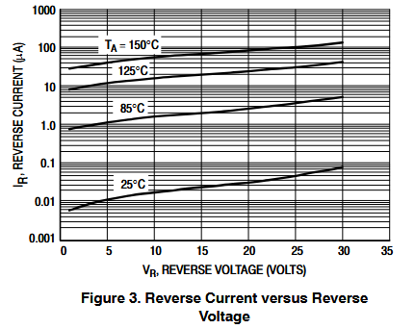

Sep 29 2025
Currently on the bus trying to figure out next steps. I want to finish this as quickly as possible, part of my strategy will be to lower scope by scrapping OT and UT. Too many strange results from that circuitry where it’s being pulled up (presumably through Q5) for no clear reason, I need more theoretical knowledge there.

I took off Q5 yesterday, next step is to take off both diodes so that Q3 and 4 are always pulled to their conducting voltage.

Next, figure out the issue with OV not working. The voltage divider isn’t giving me the right voltage.

Two options:
- Replace resistors with lower value resistors (solder on temp leaded resistors)
- Graph MODULE+ vs divider voltages and see if it’s a linear trend. If not, the comparator is messing with the circuit, like ltSPICE showed, it could be sourcing current.

I’ll try option 2 first, hopefully the PCB is in a working enough state after disabling OT and UT.

Ok microcontrollers are actually underrated, the Czech guy certainly made the right choice. Interesting exercise though!

For me to really understand the issue I need more theoretical knowledge, which will mostly come from reading practical electronics for inventors. So, getting this project in a state close to finished should be my priority, to make acquisition of theoretical knowledge the new priority. (I’ll be looking into chemical reactors and fluids systems not EE, but the principle still stands - find critical path to Terraform).

Now, to real testing a few hours later.

I took off the diodes and have still got 0.9 V on Q3/5 gate. Will need to use a stronger pull up than that 1 M.

I’ve also got a 0.4 V drop over Q2, even when adding another 200 ohm pull down on its gate. I’ve got to replace that FET, I think that’s the only solution.

Replaced the FET and i’ve still got a drop from 2.96 to 2.32 V. This isn’t dependent on load resistance either (except for a few 10s of mV).

The FET gate was at 0 V, this is not what it’s supposed to be it should be 5 V, so it’s a comparator issue. Voltage divider issue actually.

Results of voltage divider tests:
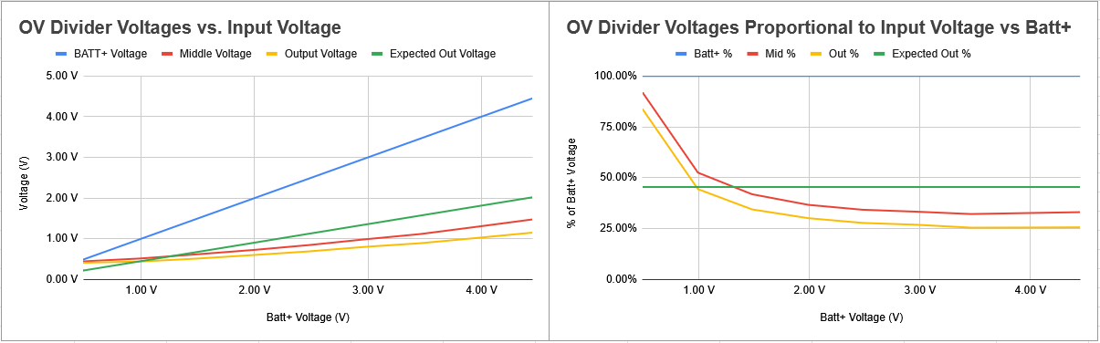
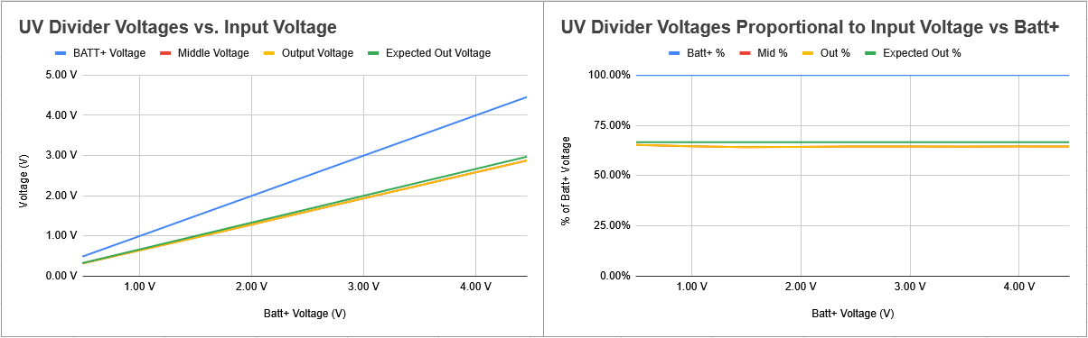

My explanation for this is that the OV comparator high rail is 5 V while the UV comparator high rail is BATT+, and the 5 V is having some interaction.

OV not working goes against what I saw earlier (the LED turned on!), so something has changed in the mean time.

Q5 Gate:

At 3.5 V Batt+, Q5 gate voltage is 0.26 V, Q5 drain voltage is 3.13 V
At 2.6 V Batt+, Q5 gate voltage is 0 V, Q5 drain voltage is 2.25 V
Batt+ Voltage | Q5 Gate Voltage | Q5 Drain Voltage
3.5 V | 0.26 V | 3.13 V
2.6 V | 0 V | 2.25 V

The gate voltage going to zero when we get below ~2.7 V (UV threshold) is a sign that MOSFETs conducting to the point of Q3 / Q4 is an issue.

Really, I just think the 1M pull down is too weak for this purpose. Well defined states are essential, and this isn’t a great way to do it.

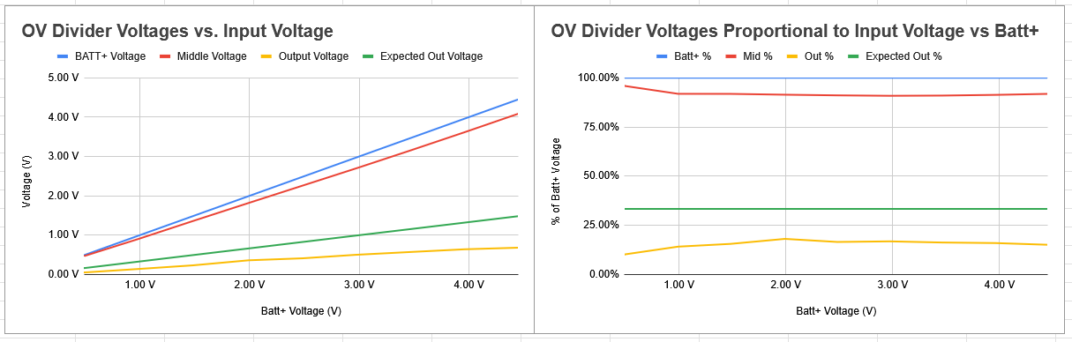

I tried to fix the OV Voltage divider problem by soldering on leaded 5k and 10k resistors, but did not get nearly the expected resistance. Next I’ll take off all resistors, probe the voltages then, and add SMD resistors back on to see what I get. If OV works, I’ll call the project complete.

https://docs.google.com/spreadsheets/d/1fG0IjSdaaXqMwqhgySdIyr8Wdc52NVvBKQQJ1HLR2iQ/edit?gid=0#gid=0

Oct 1 2025
I tried the voltage divider 5k / 10k test again and divider output voltage is dropping.

Even stranger, when PSU is turned off I get -0.25 V on the output and ~0.1 V on the middle of the top of the voltage divider. -0.5 V when PSU GND is disconnected.

-0.5 V disappears when I unplug the PSU positive probe.

Waiting a while at 4 V, I got the OV divider voltage to converge to ~2.25 V, the path it took was down to 1.6 V, bouncing around up to 2.3 V, then to 2.25 V, very sporadic.

Also, now regardless of the comparator inputs it never outputs high.

UV comparator still working, maybe the comparator is just fried. Worth a shot, I’ll replace it now. Homework is clearly less important than an internship at Impulse Labs or Terraform, or Tesla!

Replaced the comparator, same result with the output, but the voltage divider output is more in line with what I expect.

I took off the 1M pull down and same result.

Oct 5 2025
Testing OC with a M-M jumper placed between GND and the output of the fuse. We go from 1 A PSU set current to ~300 mA, and it heats up to ~37 C after ~30-60 seconds (not completely precise infrared thermometer).

Strange that it doesn’t go straight down to 0 A, PTC fuses aren’t regular fuses, they seem to just limit current or increase resistance.

Resistance increases from ~1 ohm to ~25 ohms when 1 A is attempted to be applied to it for ~10 seconds (~400 mA was the current it went to).

UT / OT circuitry works (it’s just a comparator).

I used an M-M jumper wire to connect the middle of the thermistor voltage divider to GND for UT and BATT+ for OT.

When thermistor is connected to GND, the UT comparator will have non-inverting input > inverting input, hence it’ll pull the output high.

When the thermistor (middle of divider) is connected to BATT+, the OT comparator will have non-inverting input > inverting input, and will output high (5 V).

In the blog post I should also mention the charge pump never really gave me a perfect 5 V.

UT and OT works (comparators at least), OC is slightly strange (PTC fuse doesn’t work how I expected), UV works, OV didn’t work, why?

